Looking for reliable and high-quality 3D printing services? Look no further than FoxxTechnologies — your trusted partner for transforming digital designs into tangible, precise, and functional 3D models. Whether you need prototypes, customized parts, or end-use products, our state-of-the-art 3D printing solutions are tailored to meet your exact needs.
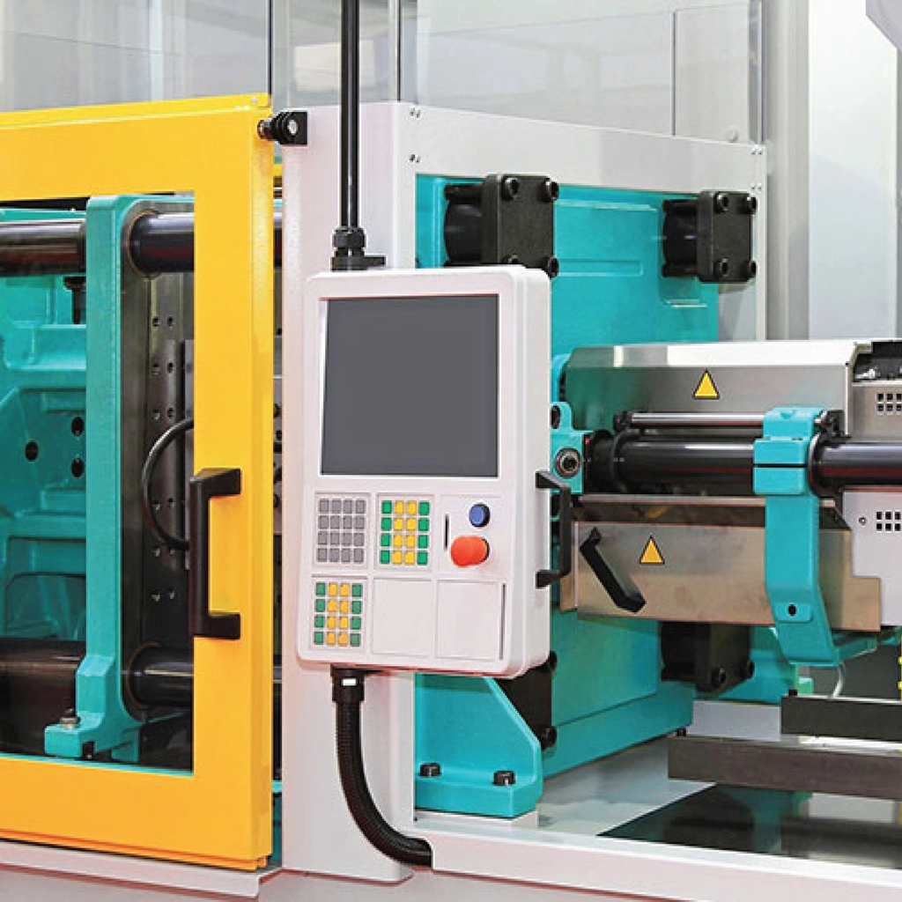
Why Choose FoxxTechnologies for 3D Printing Services?
At FoxxTechnologies, we combine cutting-edge technology with expert craftsmanship to deliver superior 3D printed products.
Here’s what sets us apart:
Advanced 3D Printing Machines: We utilize the latest in 3D printing technology, including FDM, SLA, and SLS printers, ensuring high precision and durability for every project.
Custom Solutions: From rapid prototyping to complex, industrial-grade parts, we offer fully customized 3D printing solutions for businesses, creators, and innovators.
Fast Turnaround Time: We understand the importance of deadlines. Our efficient processes guarantee prompt delivery without compromising quality.
Affordable Pricing: Quality 3D printing doesn’t have to break the bank. FoxxTechnologies provides competitive pricing options for all project sizes.
Our 3D Printing Capabilities
Prototype Development
Custom Parts Manufacturing
3D Model Designing and Printing
Industrial and Mechanical Components
Art, Fashion, and Creative Projects
Whether you're a startup looking to test your product idea or a manufacturing company needing high-volume production parts, FoxxTechnologies has the expertise and technology to bring your concepts to life.
Get in Touch with FoxxTechnologies Today!
Ready to start your 3D printing project? Contact FoxxTechnologies for a free consultation and get a quote tailored to your requirements. Experience the perfect blend of innovation, quality, and customer service in the world of 3D printing services.
Contac US : info@foxxtechnology.com
https://www.linkedin.com/company/foxxlifesciences
https://twitter.com/foxxlifescience
https://www.facebook.com/foxxlifesciences

