Breast Reconstruction After Mastectomy – Restore Confidence with Expert Care
Breast reconstruction after mastectomy is an important step in the healing journey for many women after breast cancer treatment. This procedure helps restore the shape and appearance of the breast after surgical removal, supporting both physical recovery and emotional well-being. Modern reconstructive techniques now offer highly natural-looking results through implants, flap surgery, or a combination of both.
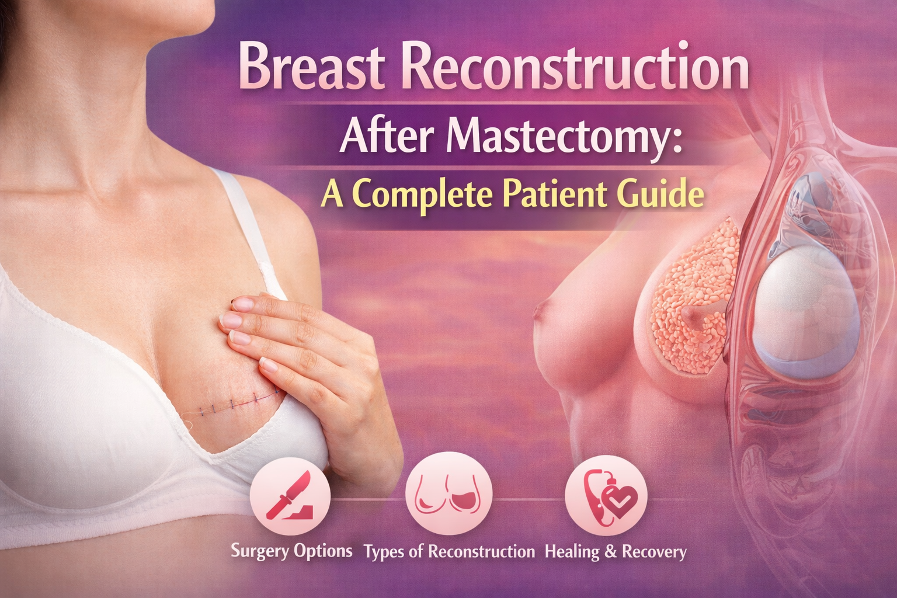
🌸 What Is Breast Reconstruction After Mastectomy?
Breast reconstruction after mastectomy is a surgical procedure that rebuilds the breast mound after breast removal surgery. It can be performed:
✔ Immediately – during the same surgery as mastectomy
✔ Delayed – weeks, months, or even years later
The procedure may use:
✔ Breast implants – silicone or saline
✔ Autologous tissue (flap surgery) – tissue taken from the abdomen, back, or thighs
✔ Combined reconstruction – tissue + implant for optimal shape
🩺 Common Reconstruction Options
Patients generally have two main choices:
Implant-Based Reconstruction
This is one of the most common options and usually involves a tissue expander followed by a permanent implant. Recovery time is generally shorter.
Flap Reconstruction
This uses the patient’s own tissue, such as DIEP flap, TRAM flap, or Latissimus Dorsi flap, to create a more natural look and feel. This option is often recommended after radiation therapy.
✨ Benefits of Breast Reconstruction
Breast reconstruction offers several life-changing benefits:
✨ Restores breast shape and symmetry
✨ Improves confidence and body image
✨ Helps emotional recovery after cancer treatment
✨ Enhances clothing fit and comfort
✨ Provides long-term natural results
For many women, this procedure plays a key role in regaining a sense of normalcy.
📍 Expert Care in Hyderabad
C For patients looking for expert treatment in Hyderabad, Dr. Divya Sai Narsingam offers advanced reconstructive options including implant and flap-based breast reconstruction after mastectomy. Her blog provides a detailed patient guide covering procedure types, recovery, and cost details.
👩‍⚕️ Recovery and Healing
Recovery depends on the chosen technique:
📌 Implant surgery – 3 to 6 weeks
📌 Flap surgery – 6 to 10 weeks
📌 Follow-up procedures like nipple reconstruction may happen later
A personalized consultation helps determine the best option based on medical history and treatment plans.
📌 Take the Next Step
If you are exploring breast reconstruction after mastectomy, understanding all available options can help you make an informed and confident decision.
contact us;drdivyaplasticsurgeon@gmail.com

